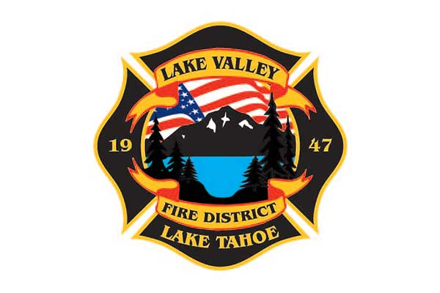
AGENDA
LAKE VALLEY FIRE PROTECTION DISTRICT
2211 Keetak Street, Meyers, CA
Meeting of the Board of Directors
4:00 pm
June 13, 2024

1. PLEDGE OF ALLEGIANCE

2. ROLL CALL

3. APPROVAL OF AGENDA

4. READING OF THE MINUTES OF THE REGULAR MEETING FOR May 7, 2024

5. PUBLIC COMMENTS

6. COMMUNICATIONS

7. OLD BUSINESS
A. JPA UPDATE
B. STRATEGIC PLAN UPDATE

8. NEW BUSINESS

- Independent Auditors report for year end June 23, 2023 with Zach Pehling
- Review and Approve Cal OES 2024 Salary Survey
- Approve Resolution 2024-1; 2024-2025 Prop. 4 Appropriation Limitation
- Approve Resolution 2024-2; Declaration of Election
- Review and Approve 2024 Conflict of Interest Code
- Review and Approve the Preliminary Budget for FY2024-2025

9. REPORTS
A. Firefighter Associations
- Local 4409
- Firefighters Foundation

B. Lake Valley Fire Protection District Chief’s Report

C. Battalion Chiefs

- Fire Marshal, Steve Pevenage
- Operations, Perry Quinn
- Training, Chuck Malone

10. REVIEW AND APPROVE District Year to Date Income and Expense Report for July 1, 2023 to May 31, 2024

11. APPROVE DISTRICT PAYROLL
A. Pay Period 10- May 10, 2024 $189,364.81
B. Pay Period 11- May 24, 2024 $196,248.19
C. Pay Period 12- June 7, 2024 $197,609.94

12. PAYMENT OF BILLS
A. May 21, 2024 $292,178.52
B. June 4, 2024 $110,968.66

13. ADJOURNMENT

Public participation is encouraged. The meeting location is accessible to people with disabilities. Every reasonable effort will be made to accommodate participation of the disabled in all of the District’s public meetings. If particular accommodations for the disabled are needed, please contact the Administrative Assistant at (530) 577-3737 at least 24 hours in advance of the meeting.

